THE SCOPE OF DIGITAL SUBTRACTION AORTIC ARTERIOGRAPHY WITH INTRAVENOUS CONTRAST MEDIUM INJECTION IN CASE OF ABSENCE OF THE TRANSARTERIAL VASCULAR APPROACH
L.S. Kokov, P.D. Matveyev, I.P. Mikhaylov, P.P. Markov
N.V. Sklifosovsky Research Institute for Emergency Medicine of the Moscow Healthcare Department, Moscow, Russian Federation

abstract | The digital subtraction aortic arteriography with the transaxillar venous approach was successfully performed in a patient with multifocal atherosclerosis and inability to underwent any transarterial procedures. Fine-quality angiographic images of the thoracic and abdominal aorta and the arteries of lower extremities were obtained. The total volume of the injected non-ionic contrast medium Ultravist-370 was 210 ml.
Keywords: | transvenous vascular approach, digital subtraction angiography, non-ionic contrast medium, Ultarvist-370.

When performing any angiographic study some difficulties related to the implementation of the vascular access often appear, particularly in patients with widespread multifocal atherosclerosis. The most common for diagnostic studies are transarterial vascular accesses: transfemoral, transradial, transbrachial and transaxillary. Translumbar access is now almost never used due to the high risk of complications, especially in inexperienced hands, and conventional angiography may be replaced by CT angiography and ultrasonic methods of research in some extent. In this clinical case, routine transarterial access was not possible to be performed due to severe atherosclerotic lesions of several arterial systems. That is why we decided to undertake a general radiopaque study of the aorta and its branches through the venous transaxillary access with the introduction of contrast medium into the superior vena cava. This technique allows angiographic images of good quality to be scanned, however, it requires more contrast medium [1-3].
Clinical case review
A 53-yaer-old male patient S. was admitted to the Institute complaining of numbness and cold left foot. Pain in the lower extremities upon walking had disturbed for the last 2 years, the present deterioration came a day before admission. Upon examination, the left lower limb was cold and pale, the sensitivity was reduced. Pulsation was absent at all levels. The right lower limb was warm and had normal color. Pulsation on the external iliac artery and common femoral artery was not defined. To develop further surgical treatment tactics we performed duplex ultrasound study and revealed: on the left - occlusion of the left common and external iliac artery; common, superficial and deep femoral artery without signs of blood flow recovery in the distal bed; on the right - occlusion of the external iliac and common femoral artery with restoration of low blood flow in the superficial and deep femoral artery. Fragments of the popliteal artery and arteries of the lower leg were seen. To clarify the status of the distal arterial bed the emergency angiography was indicated. In connection with occlusion of both common femoral arteries we denied the transfemoral arterial access. We selected the left transaxillary as the pulsation was the best there. The introducer 5F was installed into the left axillary artery, but we did not manage to put the guide through the aorta. Angiography performed through the introducer revealed an occlusion in the proximal left subclavian artery (Fig. 1). The introducer was removed, followed by hemostasis. After that, we performed a series of unsuccessful attempts ​​to puncture the right axillary artery (thready pulse). Then, the left axillary vein was punctured, the catheter was put through and installed in the superior vena cava.
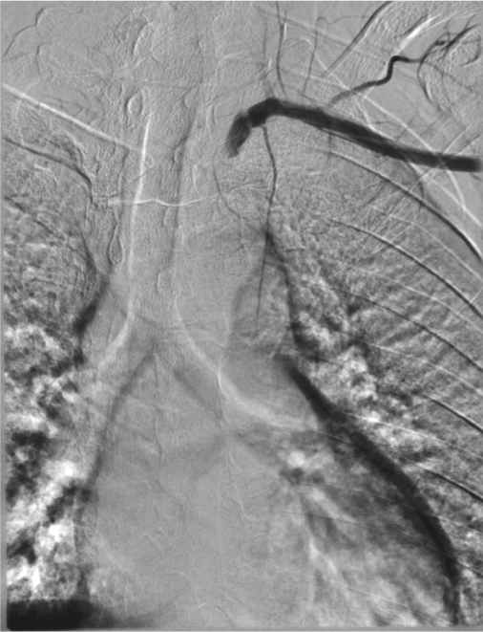

Fig. 1. The occlusion of the left subclavian artery in the first segment

To ensure acceptable quality of imaging, given the large volume of distribution of contrast medium, single injection was increased to 40 ml, and the speed - up to 20 ml/sec, which is twice the amount of contrast agent we normally use to perform the general aortic and arterial angiography. There were no contraindications to introduction of a contrast agent. Dysuria and changes in the biochemical analysis of blood and had not been subsequently identified. Total 210 ml of "Ultravist-370" contrast medium were introduced. We made a series of 5 images (Fig. 2-6), followed by an additional increase in image contrast using postprocessing mode. We obtained images of thoracic and abdominal aorta, iliac, femoral, popliteal segments and leg arteries. On angiograms: occlusion of the left subclavian artery and the right subclavian artery stenosis of 60%, steal syndrome generating from the site of the left vertebral artery. We also revealed occlusion of the left common and external iliac artery, common femoral artery with restored blood flow in the deep femoral artery. Superficial femoral artery occlusion throughout the whole length with restoration of major blood flow in the popliteal artery. Leg arteries were passable. On the right - occlusion of the common femoral artery and the proximal part of the superficial femoral artery with restored blood flow in the deep femoral artery and distal superficial femoral artery. Popliteal artery and arteries of the lower leg were also passable.
Fig. 2. The "left" phase of contrasting. Occlusion of the left subclavian artery, steal syndrome, stenosis of the right subclavian artery of up to 60%

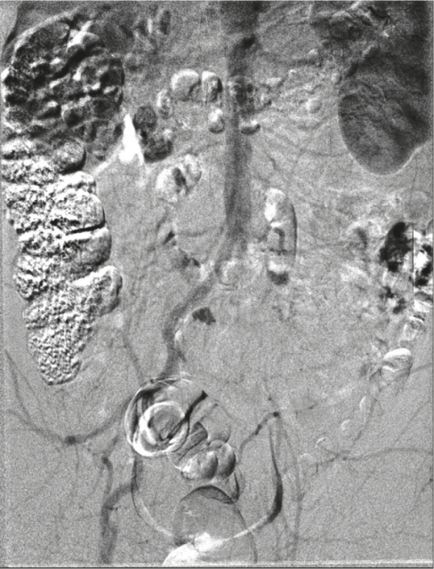
Fig. 3. Occlusion of the common iliac artery and external iliac artery on the left, passable right common iliac artery and external iliac artery
Fig. 4. Common femoral arteries occluded on both sides. Major blood flow is restored in the deep femoral arteries, through the system of parietal and visceral collaterals
Fig. 5. Major blood flow restoration in the superficial femoral artery on the right and the popliteal artery on the left
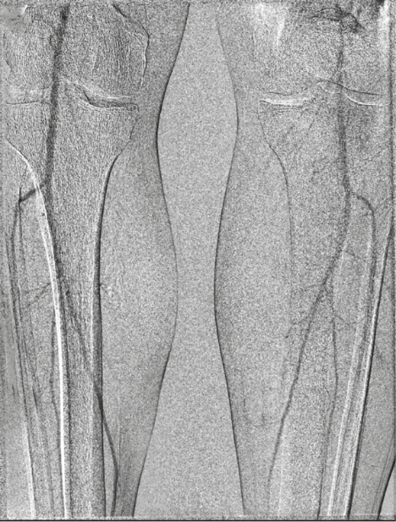
Fig. 6. Passable popliteal arteries and leg arteries

The satisfactory condition of the distal arterial bed made it possible to carry out the replacement of the aortic-femoral bifurcation with a good clinical effect. The patient was discharged in satisfactory condition two weeks after the surgery.
conclusion
The transvenous digital aortic and arterial angiography is an alternative when any of the standard transarterial approaches in patients with multifocal atherosclerosis are impossible to be performed. The use of radiopaque materials with a high iodine content ("Ultravist-370" in this study) and the post-processing editing of images provide an acceptable visual quality.

References
1. Kingsley D.P.E., Butler P., Rowe G.M., et al. Digital subtraction angiography (DSA). Neuroradol. 1989; 31: 240–246.
2. Meaney T.F., Weinstein M.A., Buonocore E., Gallagher J.H. Digital Subtraction Angiography: Cleveland Clinic Experience. Front Eur Radiol. 1982; 2: 91–102.
3. Beyer D., Gross-Fengels W., Neufang K.F. Digital subtraction angiography: The intravenous approach. Int J Card Imaging. 1988; 3 (1): 13–20.

Article received on 9 June, 2015
For correspondence:
Pavel Dmitriyevich Matveyev,
Physician of the Interventional Radiology Department.
N.V. Sklifosovsky Research Institute for Emergency Medicine of the Moscow Healthcare Department, Moscow, Russian Federation

e-mail: mpaveld@gmail.com

