Botulinum toxin for the treatment of chronic headache
L.B. Zavaliy, S.S. Petrikov, G.R. Ramazanov
N.V. Sklifosovsky Research Institute of Emergency Medicine of the Moscow Healthcare Department, Moscow, Russian Federation

abstract
The article deals with the use of botulinum toxin in the treatment of chronic headache. We present four clinical cases of patients who sought treatment in the “Pain Clinic” of N.V. Sklifosovsky Research Institute for Emergency Medicine with a chronic severe cephalgic syndrome of different genesis (migraine, tension headache, dystonia), which had not responded to outpatient treatment for a long time. The paper shows the change of pain in patients with various forms of headache after treatment with botulinum toxin type A, indicating the effectiveness of the method in these patients.
Keywords: headache, botulinum toxin.

Treatment of headache is an extremely urgent problem of modern neurology. As per the International Classification of Headache Disorders (2013), headache is subdivided into a primary headache (not associated with other diseases), a secondary headache (symptomatic, associated with other diseases, and a painful cranial neuropathy [1]. The most common patients at the neurologist's are those with the primary headache: migraine (11-22%), and tension headache (40-65%) [2]. It should be noted that a chronic headache patient has to take a large amount of pain relieving medications that may cause the development of a secondary medication-overuse headache. This form of headache develops as a result of using one or more pain relievers for more than 3 months to cope with a headache attack or for a syptomatic headache treatment. The therapy for the medication-induced headache involves a withdrawal of the pain relieving drug, undertaking detoxification measures (using glucocorticoids) as a bridge to administration of alternative pain relief medication. Flupirtine (a selective neuronal potassium channel opener) is the drug most commonly offered as an alternative pain reliever, but the drug is not potent enough, and the patient resumes taking a usual drug that causes a medication-overuse headache. This creates a vicious circle which can broken via offerring a new treatment for the headache to the patient. Botulinum toxin therapy is one of such treatments.
The effect of botulinum toxin Type A in the treatment of various headache forms has been proven in 57 clinical studies that involved more than 7,500 patients with migraine, tension headache, chronic daily headache, cervicogenic headache, and craniocervical forms of focal dystonia [3].
The scheme of botulinum toxin type A therapy for a headache is chosen after having made the diagnosis based on the patient's history, physical examination, and additional test results. There is a "fixed site fixed dose" treatment protocol where a fixed dose of the drug is to be administered to strictly defined sites. Thus, the therapy for typical migraine attacks implies 31 drug injections of 5 units each placed at prescribed locations in the head and neck muscles [4]. The treatment strategy called "follow the pain", is used in the treatment of other forms of headache with regard to its localization. A combination strategy using various methods is the most commonly used one.
In 2015, the N.V. Sklifosovsky Research Institute of Emergency Medicine established the "Pain Clinic" designated for rendering care to patients with a severe chronic pain syndrome that can not be coped with at an out-patient basis. Patients with complaints of headache shall be referred to a neurologist for consultation, where, after additional evaluations, the treatment tactics is determined, including the need for Botulinum toxin.
Since the beginning of 2015, there have been 6 patients with headache who turned to the "Pain Clinic" for a medical treatment and had the indications to botulinum toxin type A administration. Three of them received planned repeated injections, the rest 3 patients are still under follow-up to determine the further treatment strategy on expiry of 3 months. The age of patients was 38 (32, 60) years old. The male/female ratio was 1/5. One patient had a diagnosis of dystonia, other 4 patients had chronic migraine, and one more patient had a tension headache. Botulinum toxin therapy was performed using the drugs Xeomin (Merz) and Botox (Allergan).
Case report No. 1.
Patient T., 40 years old, attended the Clinic complaining of the pain in the right half of the face, head, and neck radiating to the right shoulder and arm, the numbness of his right hand. The patient had been diagnosed with congenital primary cervical dystonia at birth. There was continuous laterokaput (head tilt) to the left and tortikaput (head rotation around its axis). At the age of 4 months, the patient started to receive the therapy (physiotherapy, massage). By the end of the first year of life, a partial regression of symptoms had been noted, however, asymmetry of the face and neck remained still persisted (Fig. 1).
Fig. 1. Patient T. at the age of 2 years old. Diagnosis: primary cervical dystonia. Laterokaput to the left and tortikaput (1), the left half of the face is smaller in size than the right half (2).

At the age of 12 years, the patient was diagnosed with vegetative-vascular dystonia due to syncope, but the treatment was not performed. At the age of 20 years old, the patient experienced infrequent headache in the right temporal region, that increased with the head turning to the right. Over time, the headache sensations spread over the right half of the face (cheek, teeth), scalp, neck; she first experienced a numbness of the right half of the face. Painful attacks became more frequent, occurred with turning the head to the right, being provoked by a drop in ambient temperature (the patient wore high-collar clothes, tried to avoid hypothermia), by the wind, with touch. The patient underwent various diagnostic tests, but the exact diagnosis was never made. She was treated with a number of drugs. A short-term beneficial effect was achieved after novocaine blockades, and an interstitial electrical stimulation of trigger points (areas with palpable tense nodules located in muscle fibers, tender to palpation, being painful, or causing discomfort while pressing). Other procedures brought no relief or even caused a further exacerbation. A year before the visit to the "Pain Clinic", the patient received a therapy with botulinum toxin type A injections into the muscles of the head and neck that brought a beneficial effect for several months. The same therapy repeated 6 months later did not give a desired effect, and further the therapy was refused due to the lack of efficacy. However, the patient reported the difference between the two courses of therapy in drug application sites. In the recent 7 years, the patient suffered from a burning headache on the right (the hair, eyes, jaw, teeth, neck, throat, arm), numbness of the right hand to complete loss of sensations, dizziness (sometimes very severe, restraining her getting out of bed) that all became permanent with varying severity, the pain started radiating to the shoulder blade, and the right interscapular region. The pain intensified in the evening, and worsened the quality of life. The patient associated the painful sensations with severe toothache and was examined by a dentist, but no pathology in the oral cavity was found. The patient reported of a restrained lifestyle, namely of using orthopedic products, avoiding hypothermia, stress, and physical exertion. Conservative therapies conducted in various hospitals, relieved the pain, but a month later the pain resumed.
By the time of her visit to the "Pain Clinic", the patient had been taking "Pentalgin N" in large doses. Her neurological status demonstrated a marked asymmetry of the face due to the flatness and a smaller size of the left half of the face, a slight tilt of the head to the left, the left shoulder girdle being higher than the right one, a trapezius muscle defiance more pronounced on the right, a forehead muscle tension, sensations of pain and tension to palpation in the occipital and cervical muscles, being more pronounced on the right, a transient hypoesthesia along the inner surface of the forearm, the ring finger, and the little finger (Fig. 2). The following diagnosis was made: right hemicrania, right-sided cervicobrachialgia, infant primary cervical dystonia, left laterokaput; a posterior cervical sympathetic syndrome with vertigo type vestibulopathy, a muscle dysfunction syndrome in the right occipital muscle, the trapezius muscle, the rhomboid muscle on the right.
Fig. 2. Patient T. at the age of 40 years. Diagnosis: right hemicrania, right-sided cervicobrachialgia, infant primary cervical dystonia, left laterokaput. The tilt of the head to the left is seen (1), the asymmetry of the face due to the flatness and a smaller size of the left half of the face (2), the left shoulder girdle is higher than the right one (3), a trapezius muscle defiance is more pronounced on the right (4)

Therapeutic injections of botulinum toxin type A, 200 units, were performed in the muscles of the head and neck using the "follow the pain" strategy. A month later after the procedure, the patient reported a significant pain relief, with rare episodes of pain after stress and physical activity that were controlled with taking non-steroidal anti-inflammatory drugs (NSAIDs). The patient reported wearing revealing clothes, swimming in the pool. And she is planning a repeated botulinum toxin therapy at 3 months after the time of the drug administration.

Case report No. 2.
Patient S., 30 years old, attended the Clinic complaining of daily pressing headaches in the temporal, frontal, and occipital areas worsen in the evening or after an emotional surge; a sense of "wrap" on the head. She first experienced cephalgia a year after her baby birth and suffered for 7 years. Conservative therapy had been inefficient. She took 3 tablets of NSAID or non-narcotic analgesics daily. Her neurological status demonstrated a bilateral neck muscle defiance, the muscle defiance in the interscapular region, the bilateral tension of fronto-occipital and temporal muscles. The diagnosis of tension headache was made. Therapeutic injections of botulinum toxin type A, 165 units, were placed in the muscles of the head, using "follow the pain" strategy. An initial improvement in the form of the permanent cephalic syndrome being transformed into the paroxysmal one was observed at the end of the 2nd week after the procedure. For convenience of efficacy evaluations, we recorded the number of days with and without headache for the period of 30 days. At 2 months after the injections, the patient reported rare, situation-dependent headaches of the previous nature that were controllable with NSAIDs or flupirtine (Fig. 3). Due to the benefits of the therapy, a repeated injections of botulinum toxin type A was performed at 3 months after the first procedure. The patient is under follow-up.

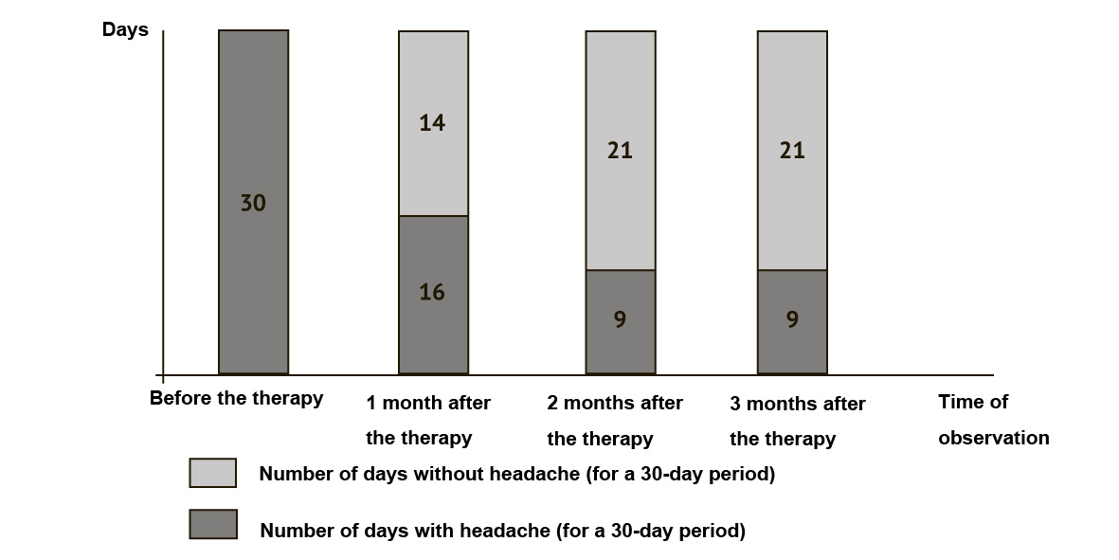
Fig. 3. The headache severity changes over time in Patient C. after botulinum toxin type A administration.

Case Report No. 3.
Patient G., 36 years old, attended the Clinic complaining of headaches as frequent as 20 days per month in the right or left half of the face and head. The pain was localized mainly in the area of an eyeball radiating to the temporal region, sometimes in the occipital region, its intensity being assessed as 9-10 points on a visual analog scale (VAS). Headache attacks were accompanied by photophobia, phonophobia, nausea, and sometimes vomiting. The attack duration reached 3 days. She had been suffering headache for 18 years. The patient did not take pain-relieving medications due to the underlying kidney disease, a chronic glomerulonephritis with an isolated urinary syndrome, Stage I chronic kidney disease. Her neurological status demonstrated a slight defiance of the trapezius muscle. The diagnosis of chronic migraine was made. Botulinum toxin therapy was conducted using the "fixed site, fixed dose" protocol: 31 drug injections of 5 units each were placed in the muscles of head, and neck. Simultaneously, additional injections of the drug, 5 units each, were placed at the trigger points in the trapezius muscle on each side, using the "follow the pain" strategy. At a month after the procedure, a positive trend of headache decreased frequency (7-8 times a month) was observed, but the pain severity remained at the previous level (Fig. 4). Given the therapy effect, a repeated Botulinum toxin therapy was undertaken 3 months later.
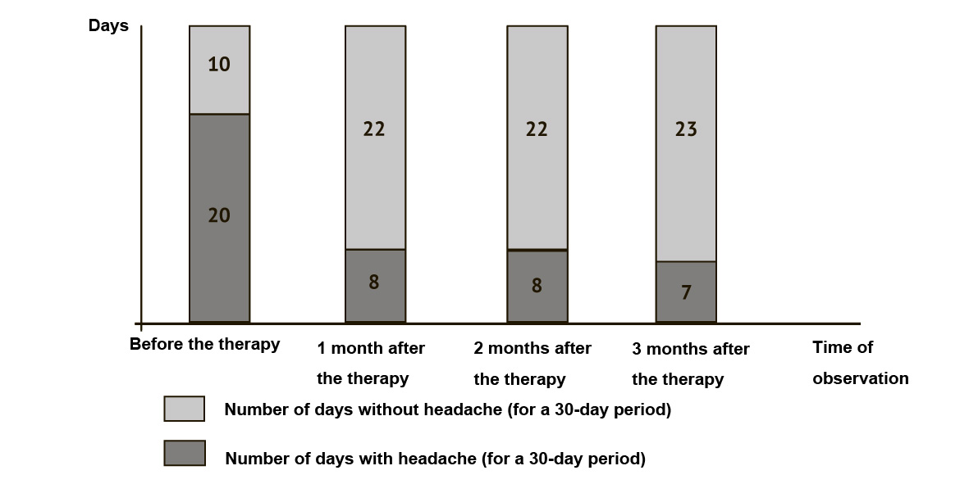
Fig. 4. The headache severity changes over time in Patient G. after botulinum toxin type A administration.

Case Report No. 4.
Patient N., 66 years old, attended the Clinic complaining of daily headaches. She described three types of headache. The first was the ache of a drilling", sometimes pulsating nature, in the right frontal region migrating to the right temporal area and the right eye. The second type was the headache, predominantly pressing by nature, in the temporal area on both sides, spreading in a helmet manner, its frequency being 15 days per month. The third type was a severe headache that occurred 1-2 times a year associated with a symptom of "lightning type" aura in front of her eyes. The patient had suffered from the illness for 30 years. To relieve the pain, the patient took up to 6 Sedalgin tablets daily. The neurological status at the moment of the physical exam demonstrated the forehead muscle tension, pain and tension to palpation in the right temporal muscle, the defiance of neck muscles, a spine deformity. The diagnosis of the chronic migraine, a medication-overuse headache was made. After the detoxification "bridge therapy" undertaken for the medication-overuse headache, a botulinum toxin therapy was offered to the patient. Following the "fixed site, fixed dose" procedure with 31 injections of Botulinum toxin type A, 5 units each, placed in the muscles of the head and neck, additional "follow the pain" injections were placed in the trigger points: 5 units on each side of the frontal muscles, 10 units in the temporal muscles. At 1 month after the injections, the patient reported a beneficial effect in the form of a decreased frequency of pain attacks to 11 per month (Fig. 5), and a pain severity reduction assessed as 5 to 6 points on the VAS. If the pain did not diminished spontaneously, the patient coped with it taking a NSAID. She completely refused from taking Sedalgin. At 3 months after the first therapy with Botulinum toxin, the headache frequency was 12 attacks per months with the severity assessed up to 4 points on the VAS (Fig. 5). A repeated Botulinum toxin therapy was performed, and currently the patient is under the neurologist's follow-up.
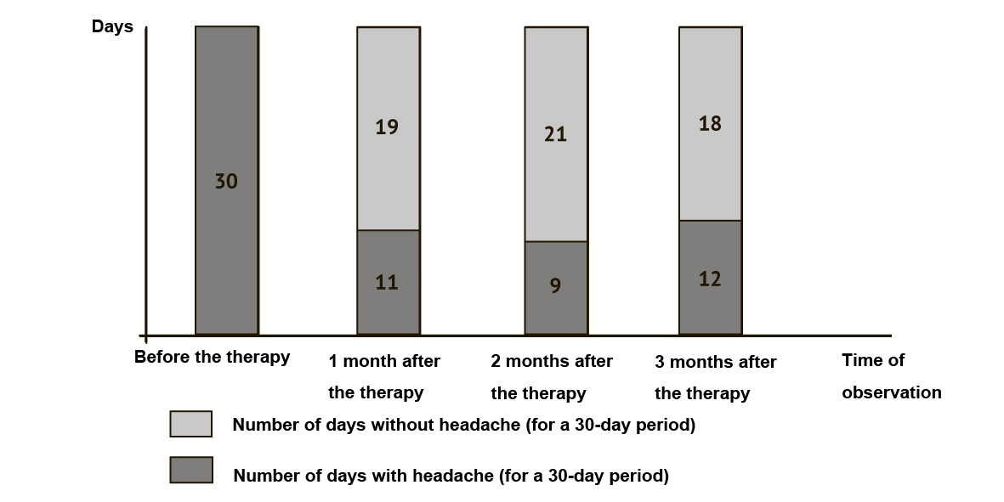
Fig. 5. The headache severity changes over time in Patient N. after botulinum toxin type A administration.

The above observations confirm the efficacy of Botulinum toxin therapy for a severe chronic cephalgic syndrome. However, the effect of the drug can vary. Some patients have demonstrated a significantly reduced headache frequency with maintained previous severity of pain attacks, while others have shown a reduced severity of pain attacks; and in some patients a durable regression of pain syndrome into a situation-dependent headache has been achieved. Worthwhile to note, the patients have completely refused from taking potent analgesic drugs such as Pentalgin N (a combination of Metamizole sodium, Naproxen, Caffeine, Codeine, and Phenobarbital) and Sedalgin (a combination of acetylsalicylic acid, Phenacetin, Phenobarbital, Caffeine, Сodeine). Importantly, the therapy with Botulinum toxin reaches the main goal of treatment, that is the significant improvement of patient's quality of life.
REFERENCES
1. Headache Classification Committee of the International Headache Society (IHS). The International Classification of Headache Disorders, 3rd ed. (beta version). Cephalalgia. 2013; 33 (9): 629–808.
2. Osipova V.V. Diagnostika golovnykh boley v ambulatornoy praktike. Golovnaya bol’: cbornik dokladov [Diagnosis of headaches in the outpatient practice. Headache: a collection of papers]. Moscow: PMGMUim. I.M. Sechenova Publ., 2013. 68 p. (In Russian).
3. Artemenko A.R., Orlova O.R., Mingazova L.R. et al. Toksin botulizma tipa A v lechenii bolevykh sindromov [Botulinum toxin type A in the treatment of pain syndromes]. Russkiy meditsinskiy zhurnal. 2008; 16 (“Bolevoy sindrom”): 40–44. (In Russian).
4. Deborah Tepper M.D. Onabotulinumtoxin A (Botox). Headache: The Journal of Head and Face Pain. 2014; 54 (4): 787–788.
Received 08/11/2015
Contact Information:
Zavaliy Lesya Bogdanovna,
neurologist of neurological Department for patients with acute stroke
N.V. Sklifosovsky Research Institute of Emergency Medicine of the Moscow Healthcare Department Moscow
e-mail: l.zav@bk.ru

